Our IPROBOT 3 support 3 protocols which are FTP, Samba and Net File System.
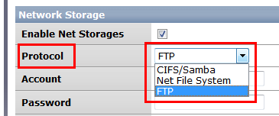
Please check whether your NAS supports them.
For FTP, the setting should be like the below.
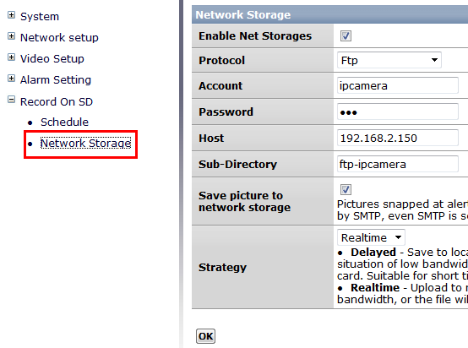
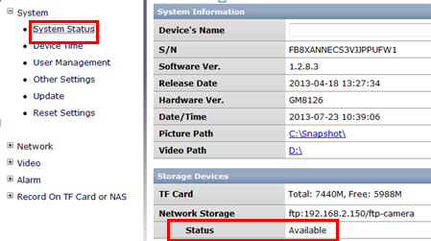
Account: User Accounts you have set for the NAS like the below.
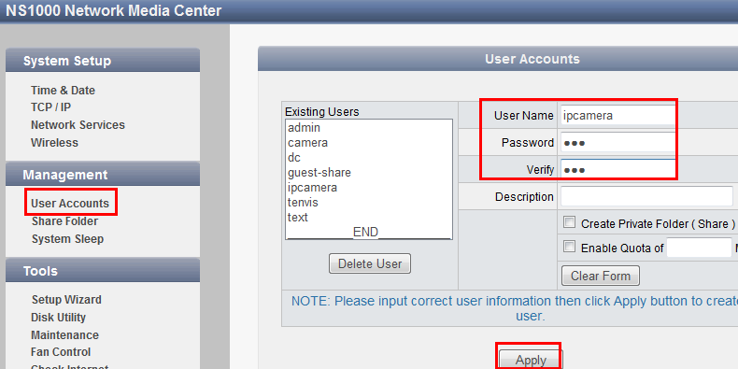
Host: The IP address of your NAS like the below.
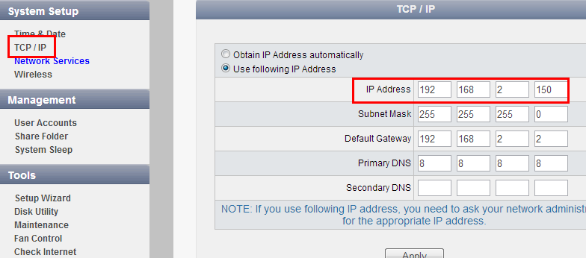
Sub-Directory: The Name from the below page.
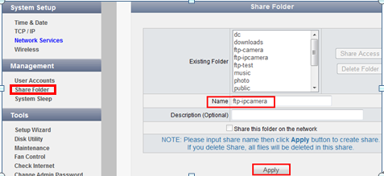
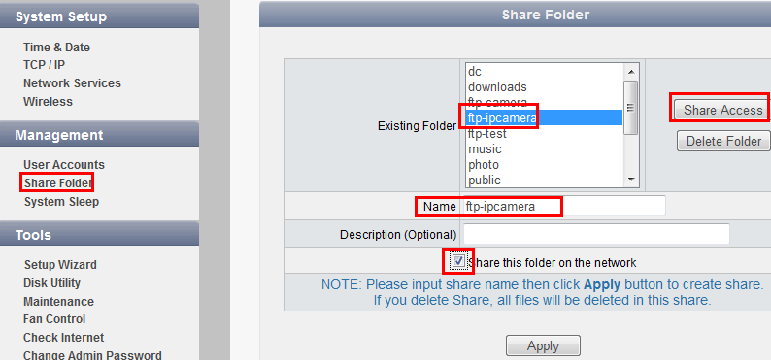

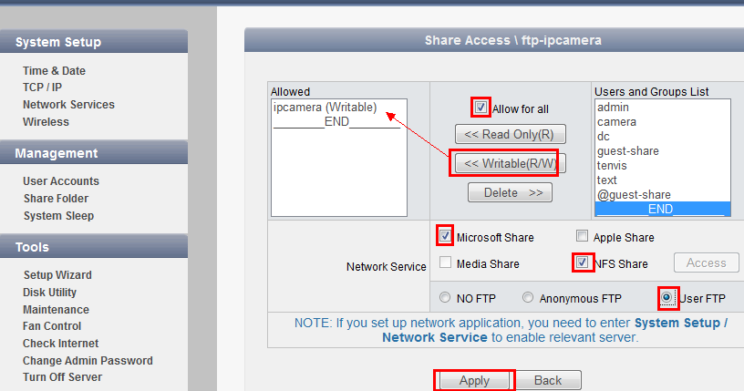
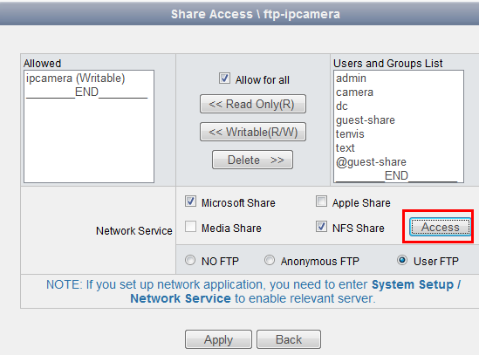
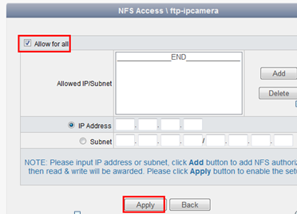
Since there are so many different kinds of NAS around the world, today we only take snapshot of our NAS for your reference. If you still can not make it work, we intend to set it for you through remote control. Thanks.

